LP-I
BE
Assignment No: - A3

Assignment No: - A3
TITLE | Parallel Sorting Algorithms
PROBLEM STATEMENT /DEFINITION | For Bubble Sort and Merge Sort, based on existing sequential algorithms, design and implement parallel algorithm utilizing all resources available.
OBJECTIVE | - To understand concept of Bubble Sort and Merge Sort based on sequential algorithm.  - To understand concept of parallel algorithm.  - To compare performance by varying number of processors used and also with sequential algorithm.
S/W PACKAGES AND  HARDWARE APPARATUS USED | Operating Systems  1. Open source Linux or its derivative  2. Master slave parallel computation model
REFERENCES | - Ananth Grama, Anshul Gupta, George Karypis, and Vipin Kumar, "Introduction to Parallel Computing", 2nd edition, Addison-Wesley, 2003, ISBN: 0-201-64865-2.
INSTRUCTIONS FOR  WRITING JOURNAL | - Date  - Assignment no.  - Problem definition  - Learning objective  - Learning Outcome  - Concepts related Theory  - Related Mathematics  - Algorithm.  - Test Cases  - Conclusion and applications

Assignment A3
- Aim
Write a program to design and implement parallel Bubble Sort and Merge Sort algorithm.

- Prerequisites
- Concept of existing sequential algorithms.
- Concept of High Performance Computing.

- Learning Objectives
- To understand concept of Bubble Sort and Merge Sort based on sequential algorithm.
- To understand concept of parallel algorithm.
- To compare performance by varying number of processors used and also with sequential algorithm.

- Learning Outcome
After successfully completing this assignment, you should be able to
- Display result for parallel Bubble Sort and Merge Sort.
- Analyze performance by varying number of processors used and also with sequential algorithm.

- Concepts related Theory :-

- Bubble Sort Algorithm:-
Sequential Bubble Sort Algorithm:
One of the straight-forward sorting methods
–Cycles through the list
–Compares consecutive elements and swaps them if necessary
–Stops when no more out of order pair.
- Slow & inefficient
- Average performance is O(n²).

Parallel Bubble Sort
Compare all pairs in the list in parallel.
When to stop?
•Shared flag, sorted, initialized to true at beginning of each iteration (2 phases), if any processor perform swap, sorted = false

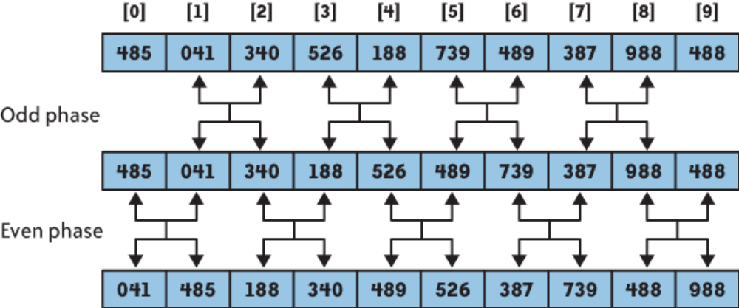

Parallel Bubble Sort Complexity
Sequential bubble sort, O(n²).
Parallel bubble sort? (if we have unlimited # of processors)
Do n-1 comparisons for each iteration => O(n)

Parallel Bubble Sort Example:
How many steps does it take to sort the following sequence from least to greatest using the Parallel Bubble Sort? How does the sequence look like after 2 cycles?
•4,3,1,2
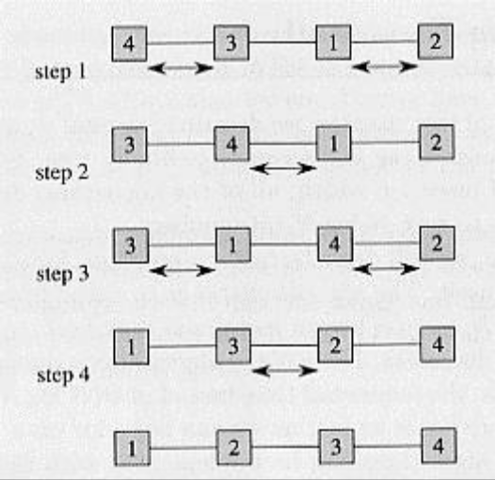

- Merge Sort Algorithm:-
Sequential Merge Sort:

Divide and Conquer:
•Dividing problem into sub-problems
•Division usually done through recursion
•Solutions from sub-problems then combined to give solution to the original problem.

Collects sorted list onto one processor
•Merges elements as they come together
•Simple tree structure
•Parallelism is limited when near the root
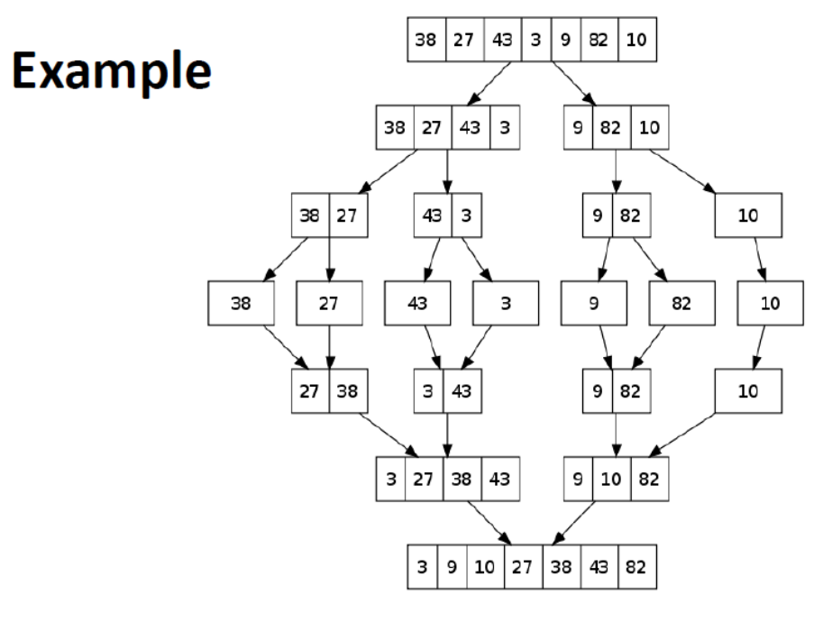
Merge Sort Complexity:
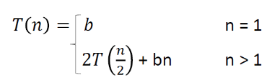
Solve the recurrence relation
T(n) = O(nlogn)
Parallel Merge Sort:
•Parallelize processing of sub-problems
•Max parallelization achieved with one processor per node (at each layer/height).

Parallel Merge Sort Example:
Perform Merge Sort on the following list of elements. Given 2 processors, P0 & P1, which processor is reponsible for which comparison?
•4,3,2,1

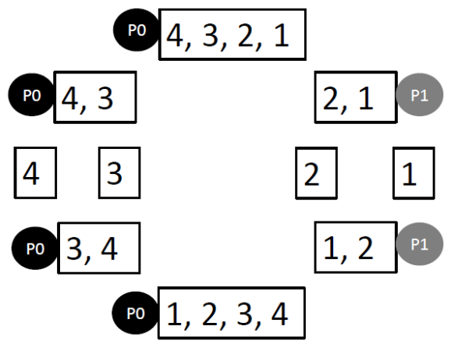

Parallel Merge Sort Complexity:
•Merge sort, O(nlogn)
•Easy way to remember complexity, n (elements) x logn (tree depth)
•If we have n processors, O(logn)

- Test Cases:
Students should write test cases depending on their input.

- Conclusion :
After successfully completing this assignment, student should be able to understand and implement parallel bubble sort and merge sort in OpenMP/MPI..

LP-I
BE
Assignment No: - A5

Assignment No: - A5
TITLE | K Nearest Neighbors Classifier using multithreading in java.
PROBLEM STATEMENT/DEFINITION | Parallel Implementation of the K Nearest Neighbors Classifier.
OBJECTIVE | - To understand concept of K Nearest Neighbors classifier.  - To understand concept of parallel algorithm.  - To compare performance by varying number of processors used and also with sequential algorithm.
S/W PACKAGES AND  HARDWARE APPARATUS USED | Operating Systems  1. Open source Linux or its derivative  2. Multithreading in java.
REFERENCES | - Ananth Grama, Anshul Gupta, George Karypis, and Vipin Kumar, "Introduction to Parallel Computing", 2nd edition, Addison-Wesley, 2003, ISBN: 0-201-64865-2.  - Java-The Complete Reference by Herbert Schildt, 7th edition.  - Introduction to Data Mining and Knowledge Discovery, Third Edition by Two Crows Corporation, pdf
INSTRUCTIONS FOR  WRITING JOURNAL | - Date  - Assignment no.  - Problem definition  - Learning objective  - Learning Outcome  - Concepts related Theory  - Related Mathematics  - Algorithm.  - Test Cases  - Conclusion and applications

Assignment A5
- Aim
Write a program to design and implement parallel K Nearest Neighbors Classifier algorithm.

- Prerequisites
- Concept of existing sequential algorithms.
- Concept of High Performance Computing.

- Learning Objectives
- To understand concept of K Nearest Neighbors Classifier based on sequential algorithm.
- To understand concept of parallel algorithm.
- To compare performance by varying number of threads used and also with sequential algorithm.

- Learning Outcome
After successfully completing this assignment, you should be able to
- Display result for parallel K Nearest Neighbors Classifier.
- Analyze performance by varying number of threads used and also with sequential algorithm.

- Algorithm :
Step 1: Initialize value of K.
Step 2: Calculate distance between input sample and training samples.
Step 3: Sort the distances.
Step 4: Take top K- nearest neighbors.
Step 5: Apply simple majority.
Step 6: Predict class label for input sample.

- Concepts related Theory :-
K-Nearest Neighbor or KNN algorithm is part of supervised learning that has been used in many applications including data mining, statistical pattern recognition, and image processing. To identify the class of an input, the algorithm chooses the class to which the majority of the input’s k closest neighbors belong to. The KNN algorithm is considered as one of the simplest machine learning algorithms.

KNN is a simple algorithm that stores all available cases and classifies new cases based on a similarity measure. In pattern recognition, the k-Nearest Neighbors algorithm (or k-NN for short) is a non-parametric method used for classification and regression. In both cases, the input consists of the k closest training examples in the feature space. The output depends on whether k-NN is used for classification or regression:
- In k-NN classification, the output is a class membership. An object is classified by a majority vote of its neighbors, with the object being assigned to the class most common among its k nearest neighbors (k is a positive integer, typically small). If k = 1, then the object is simply assigned to the class of that single nearest neighbor.
- In k-NN regression, the output is the property value for the object. This value is the average of the values of its k nearest neighbors.
k-NN is a type of instance-based learning, or lazy learning, where the function is only approximated locally and all computation is deferred until classification. The k-NN algorithm is among the simplest of all machine learning algorithms.
The neighbors are taken from a set of objects for which the class (for k-NN classification) or the object property value (for k-NN regression) is known. This can be thought of as the training set for the algorithm, though no explicit training step is required.
A shortcoming of the k-NN algorithm is that it is sensitive to the local structure of the data. The algorithm has nothing to do with and is not to be confused with k-means, another popular machine learning technique.

- Test Cases:
Students should write test cases depending on their input.

